**Week 4**

**Logistic Regression**

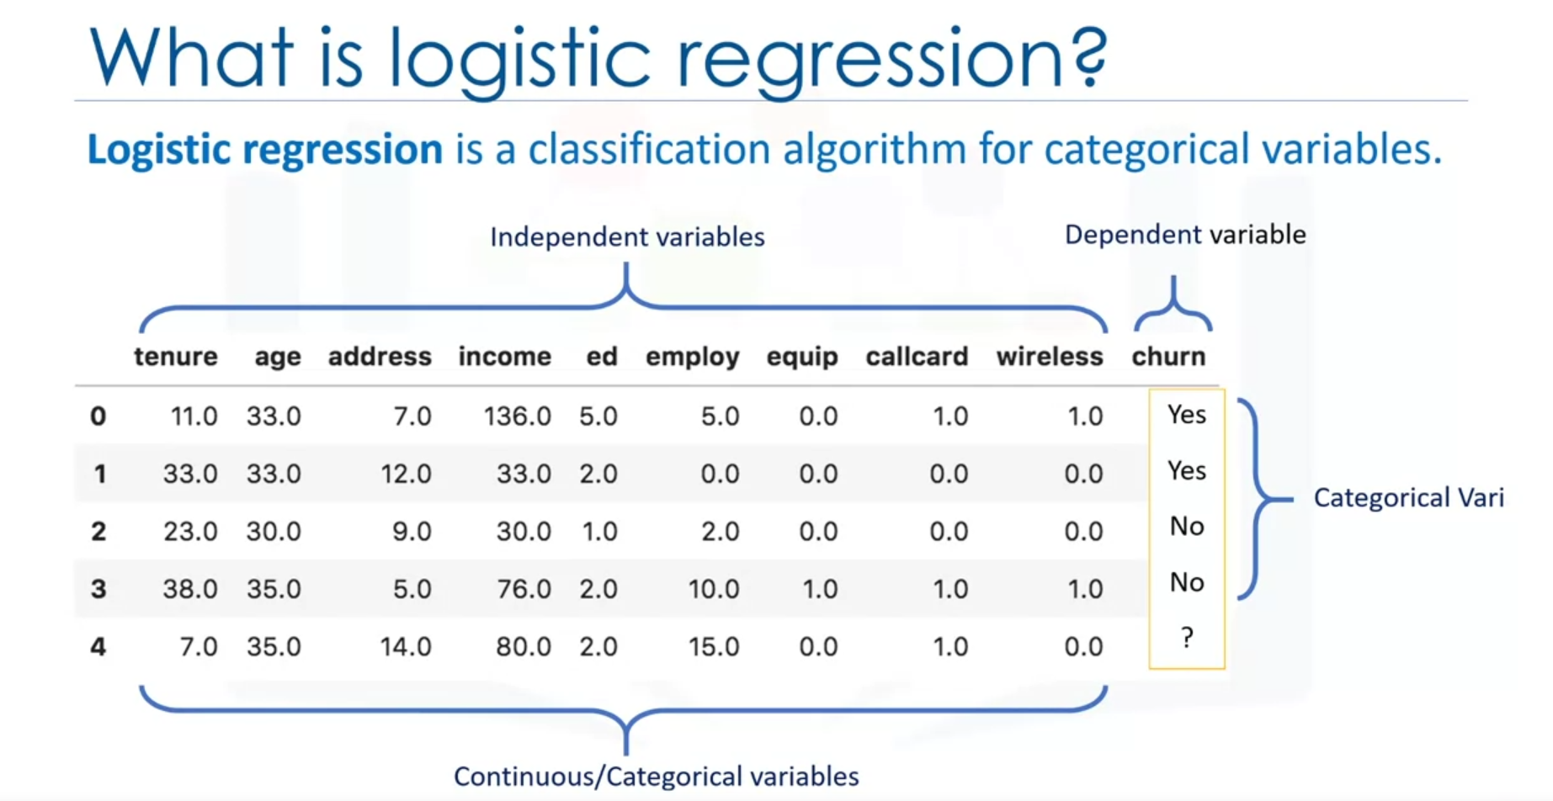

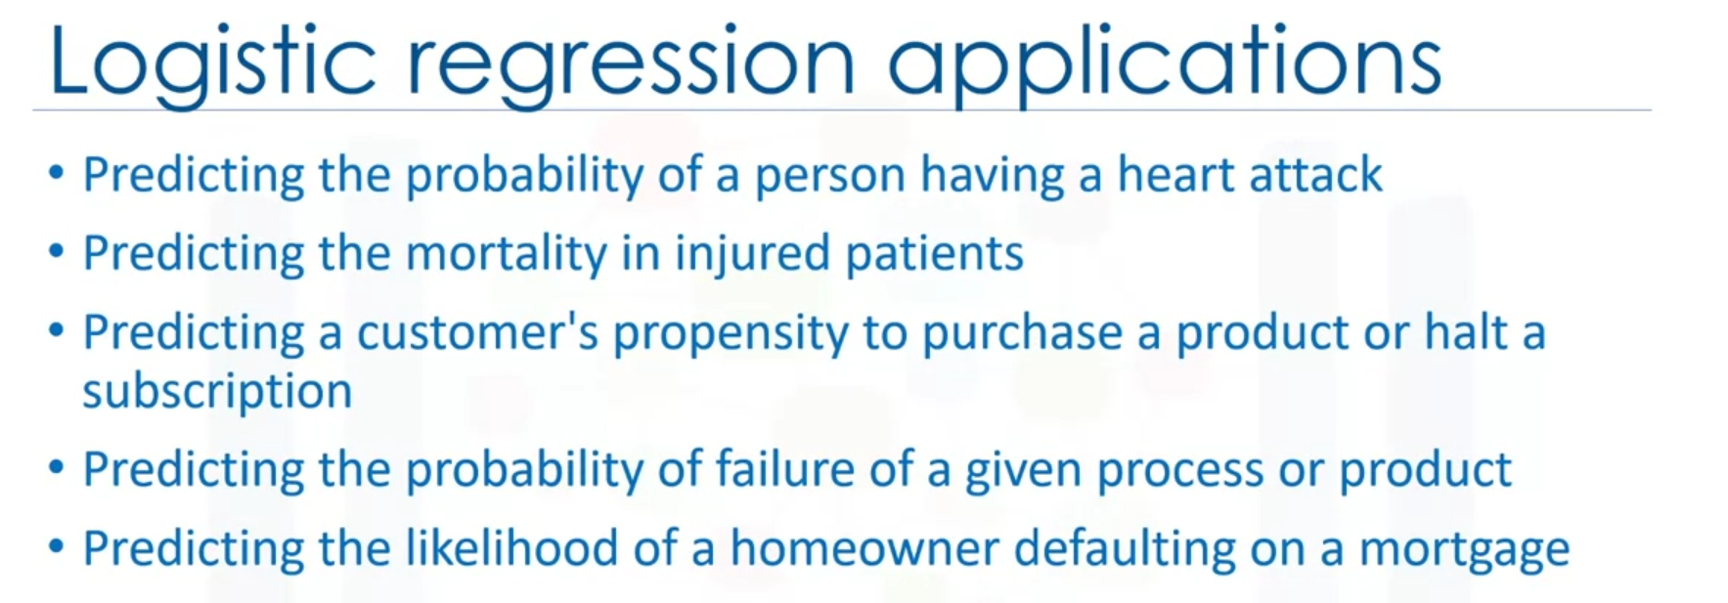

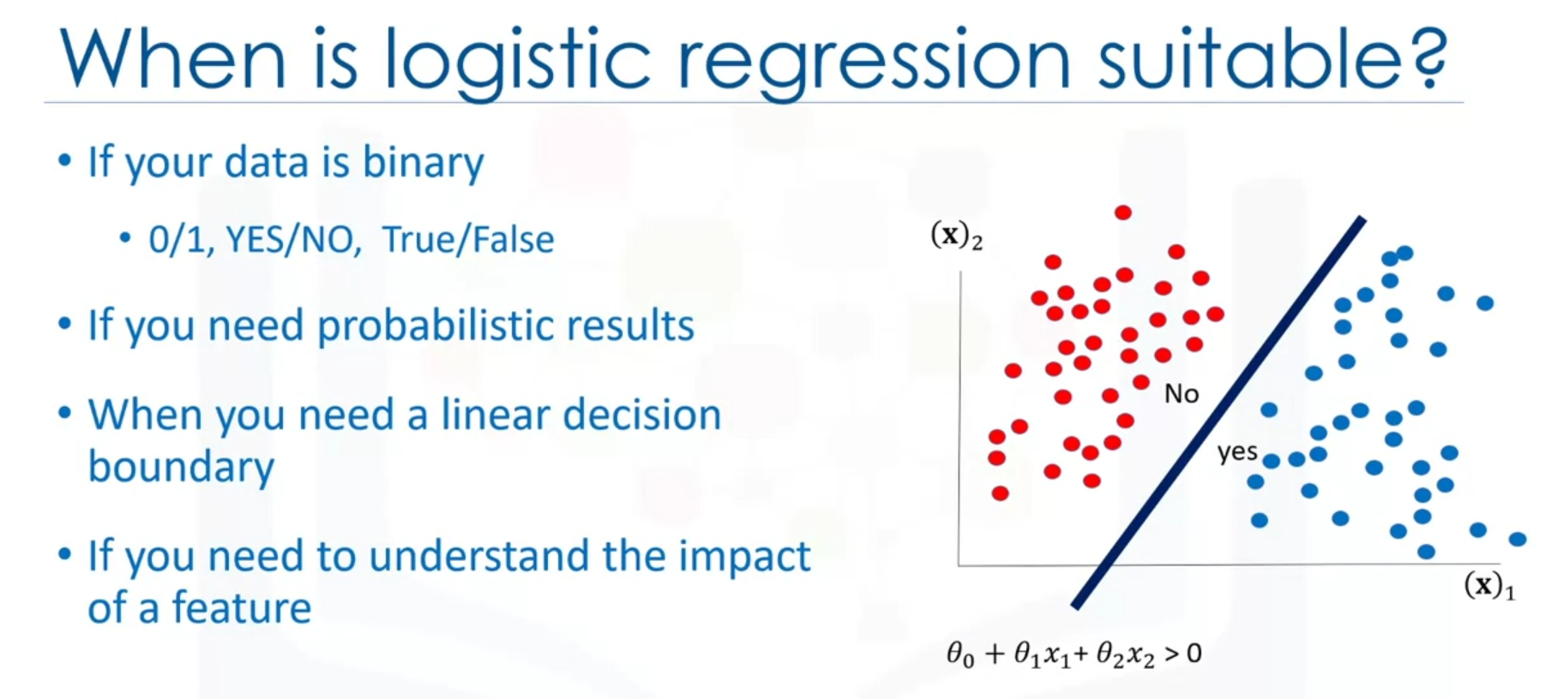

* Logistic regression is analogous to linear regression but takes a categorical/discrete target field instead of a numeric one.
* Logistic Regression measures the probability of a case belonging to a specific class.
* Logistic Regression can be used to understand the impact of a feature on a dependent variable.

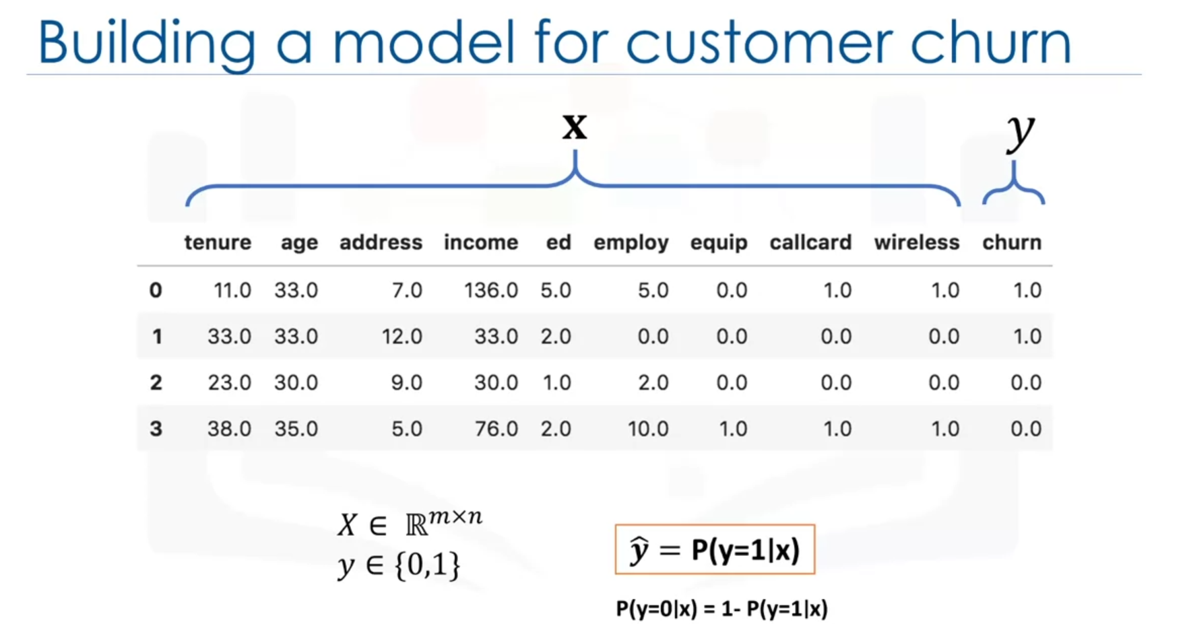

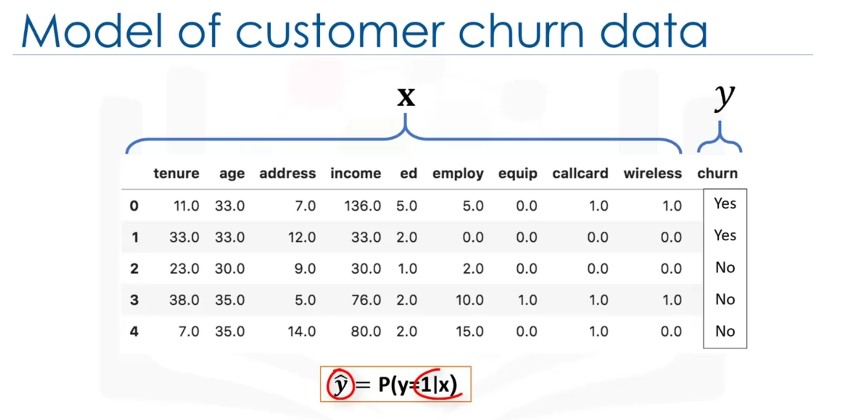

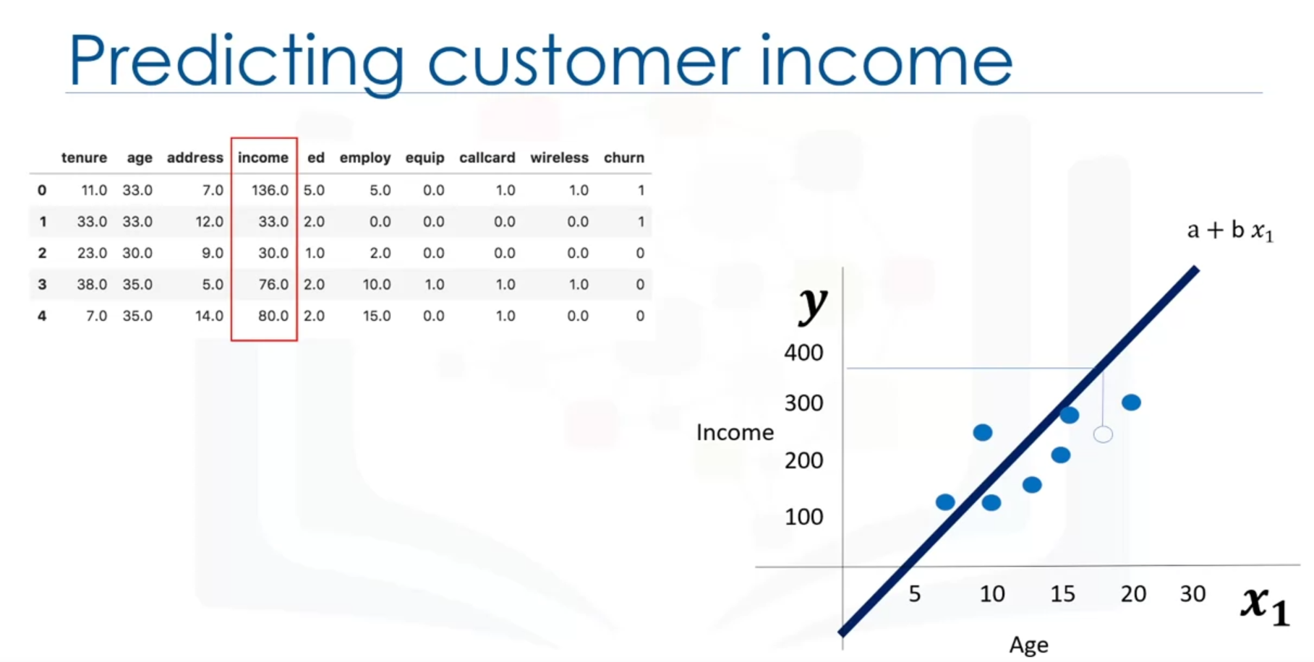

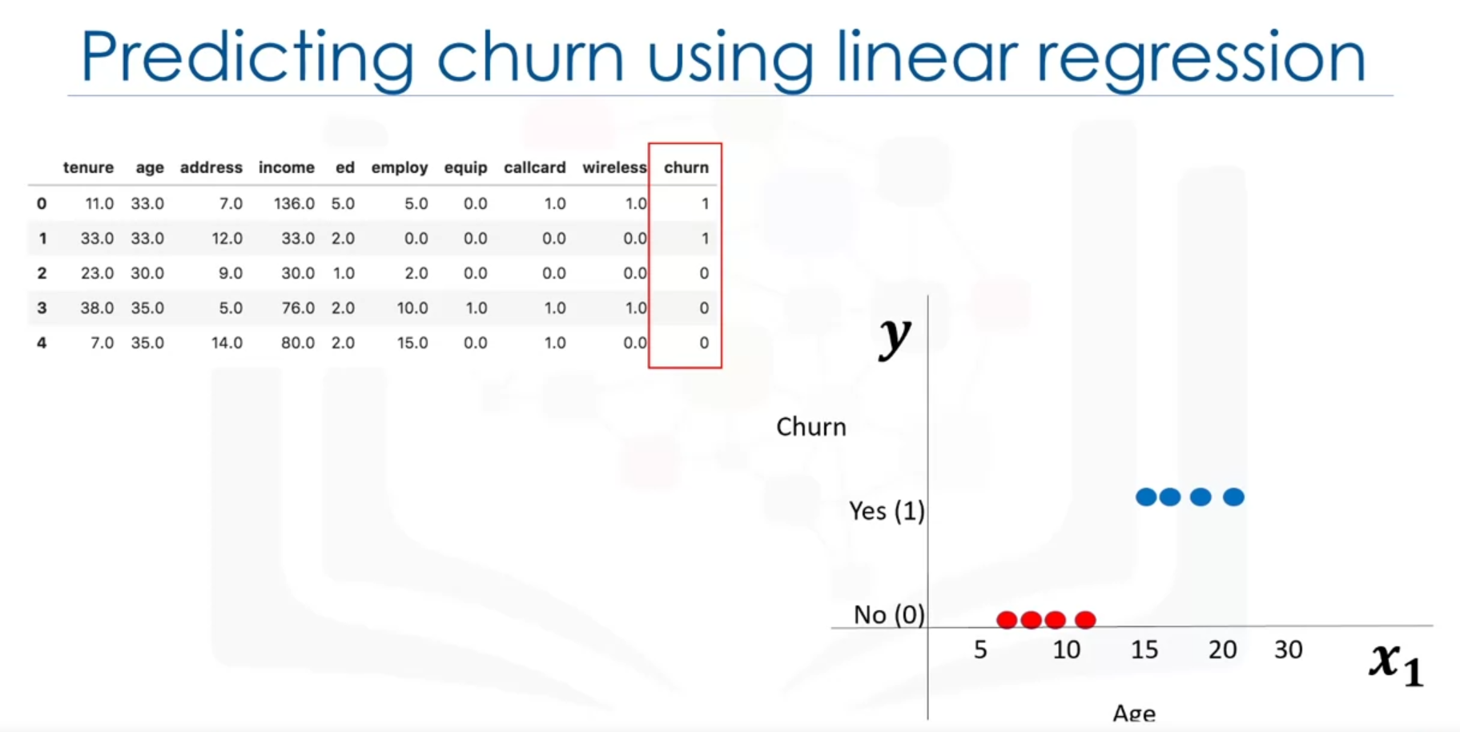

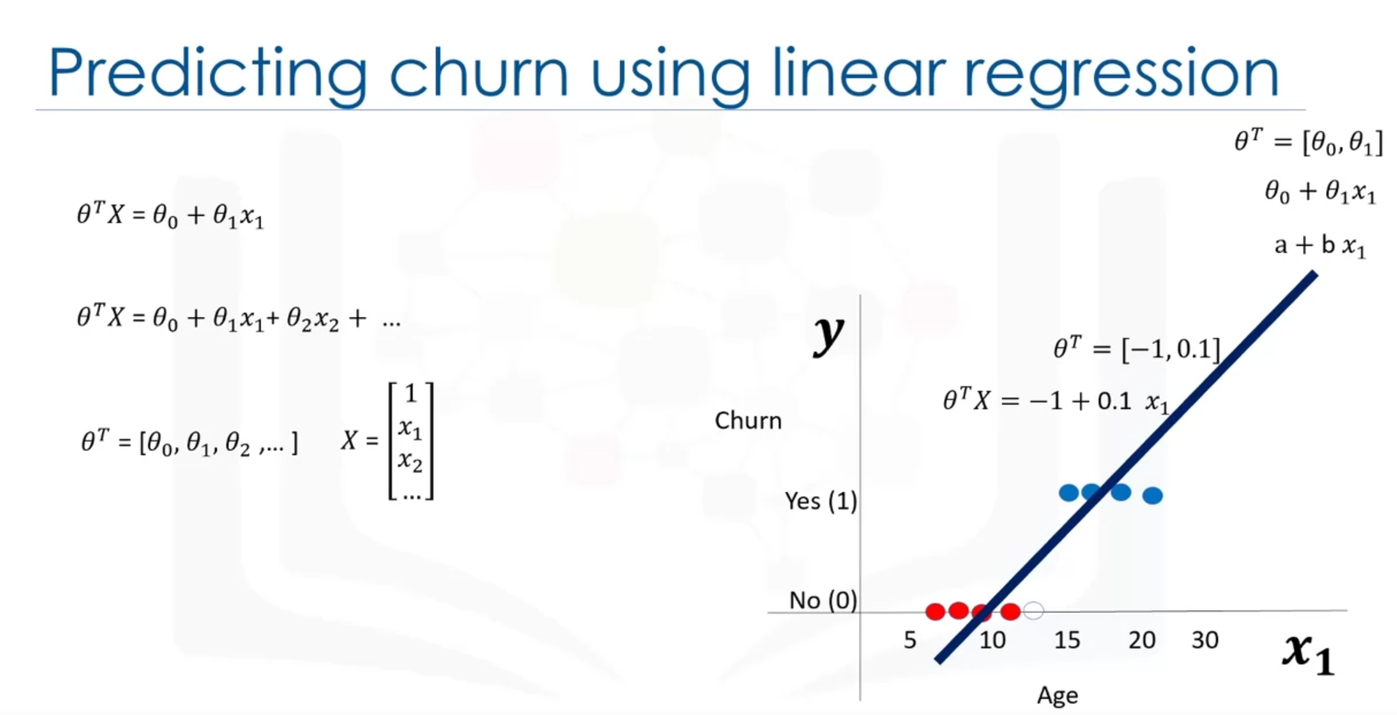

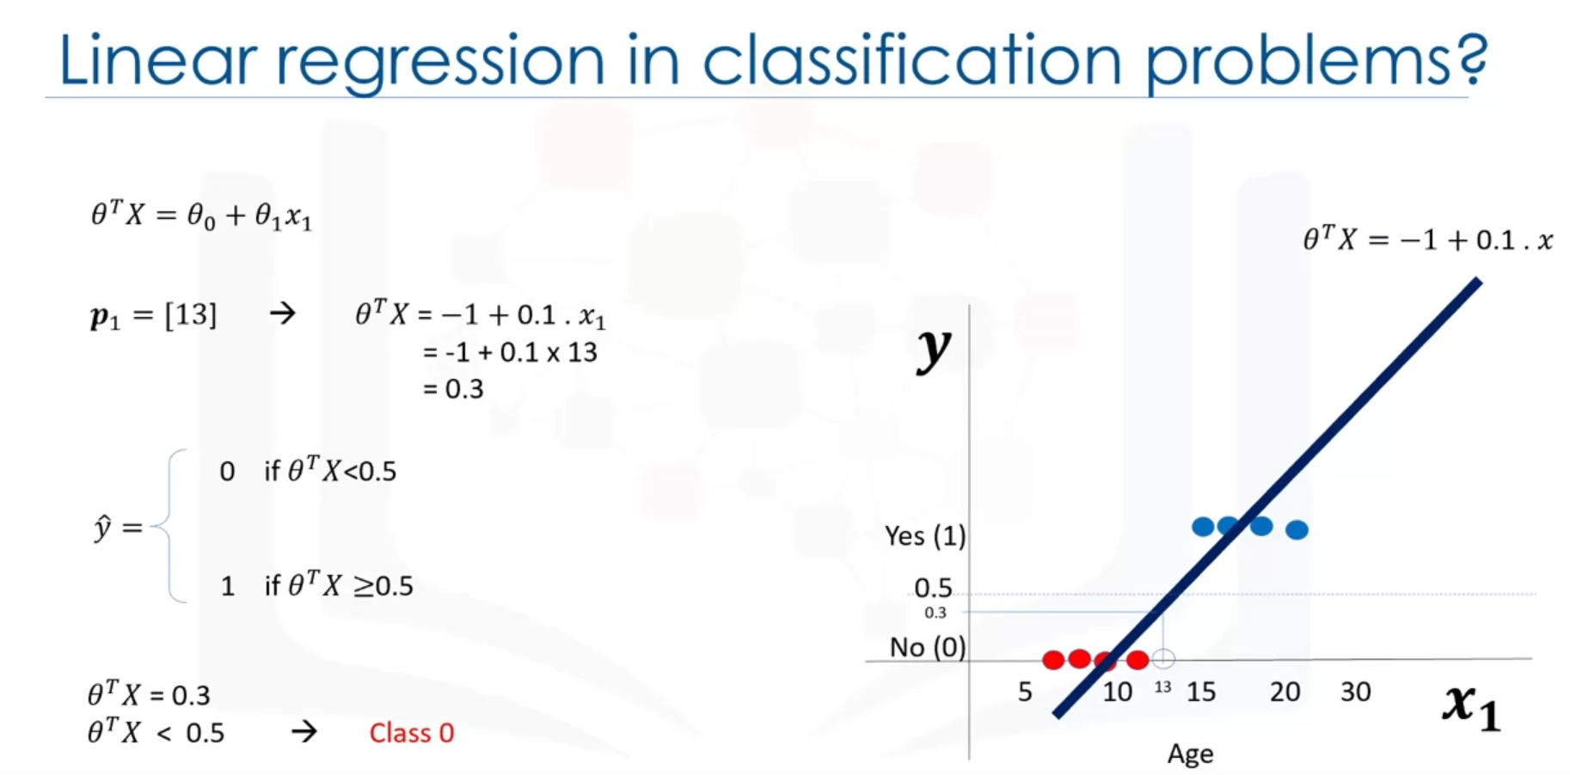

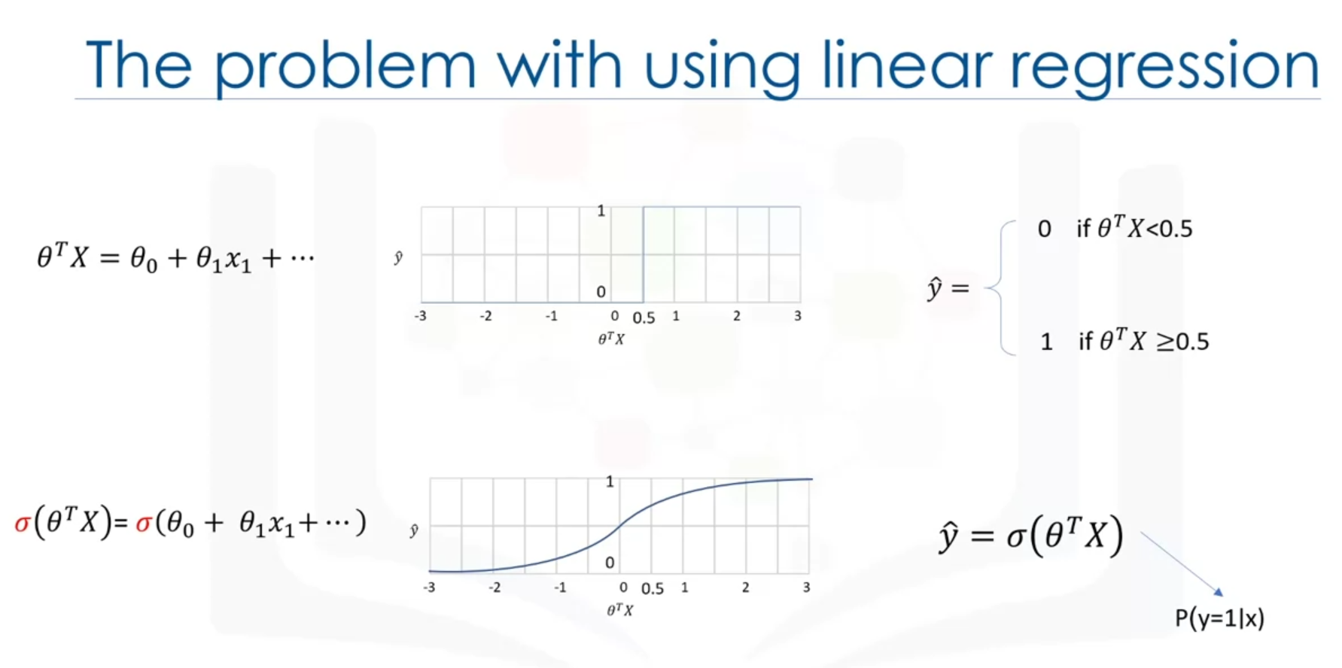

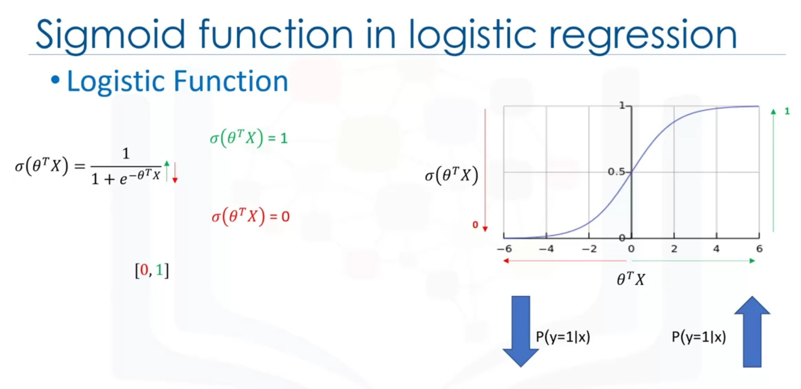

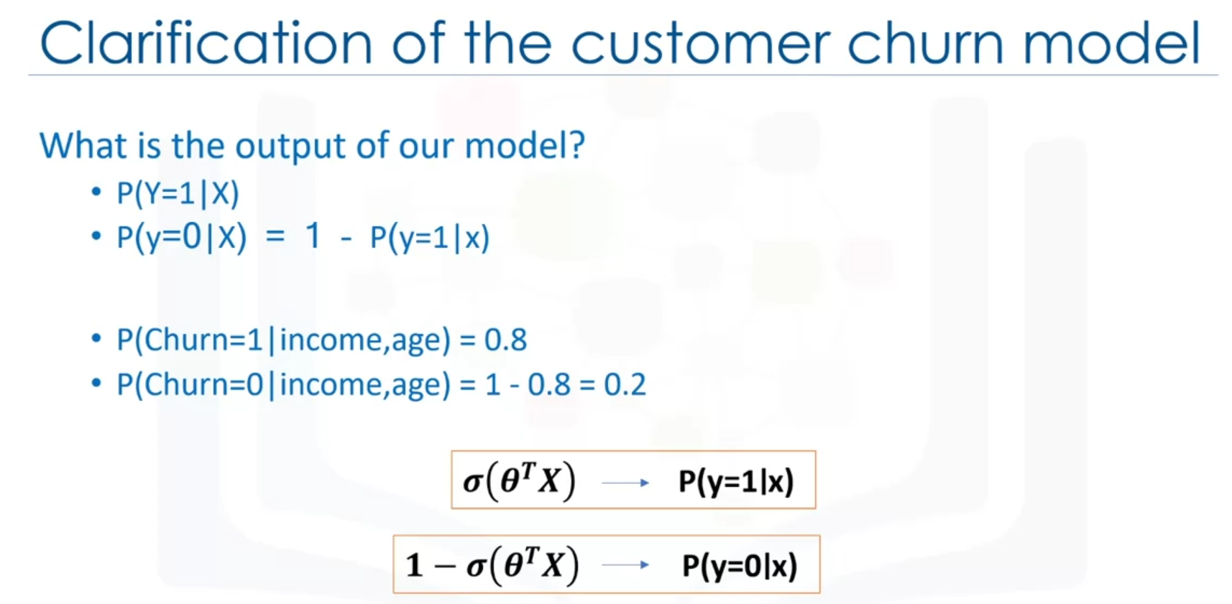

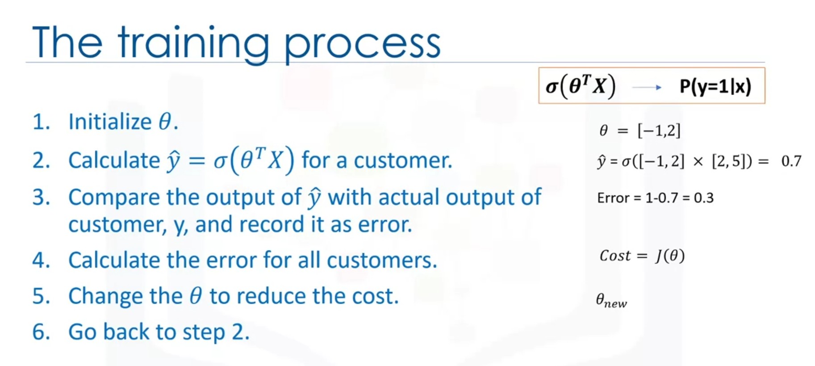

What is difference between Linear Regression vs Logistic Regression, in solving a classification problem? Linear Regression cannot properly measure the probability of a case belonging to a class.

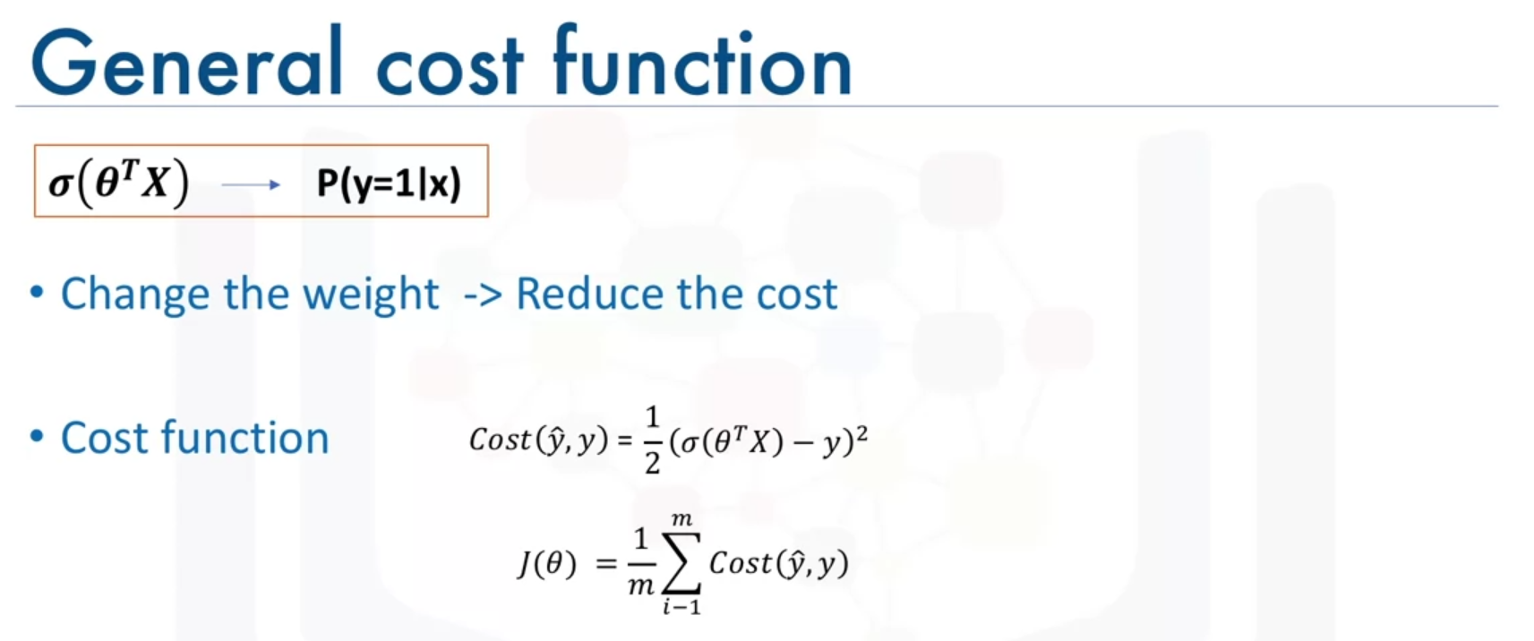

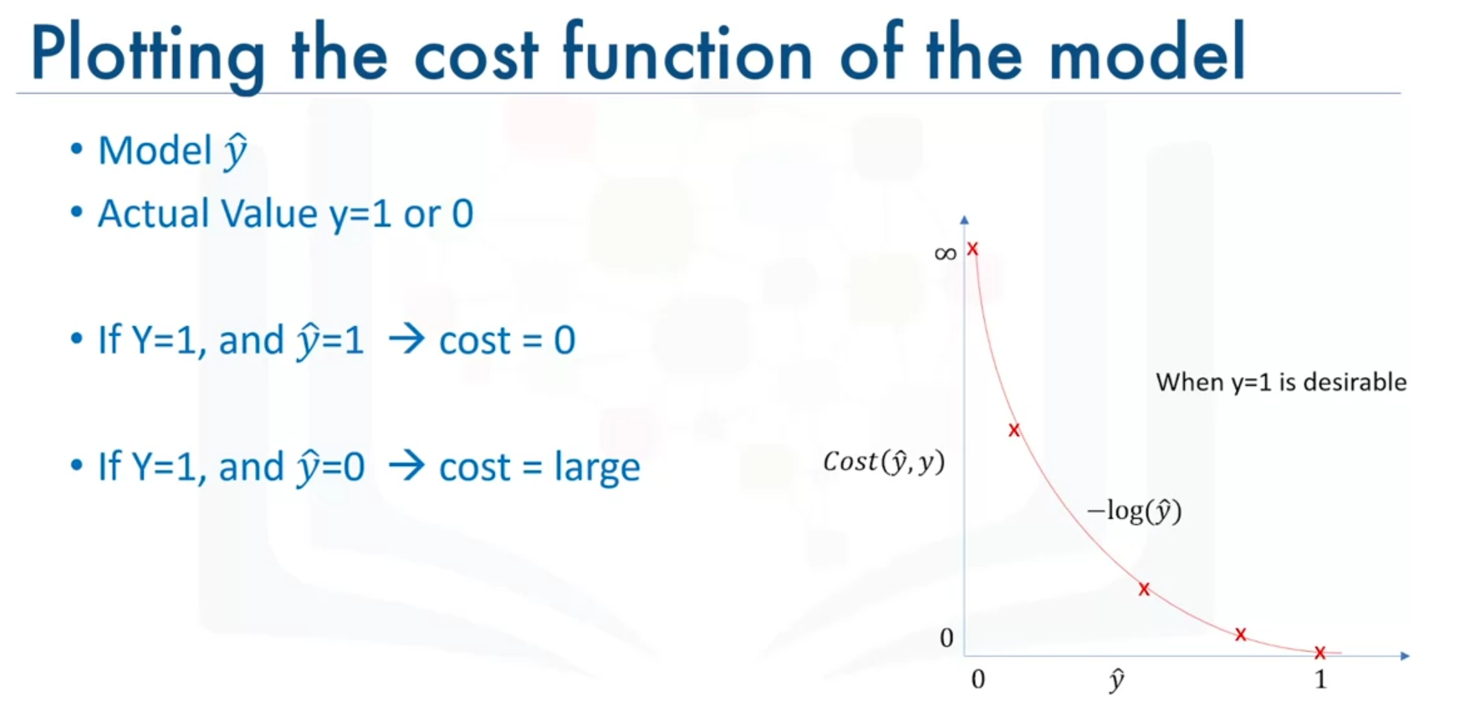

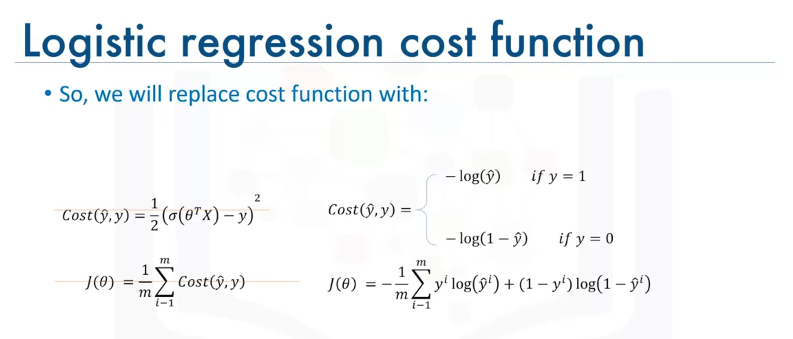

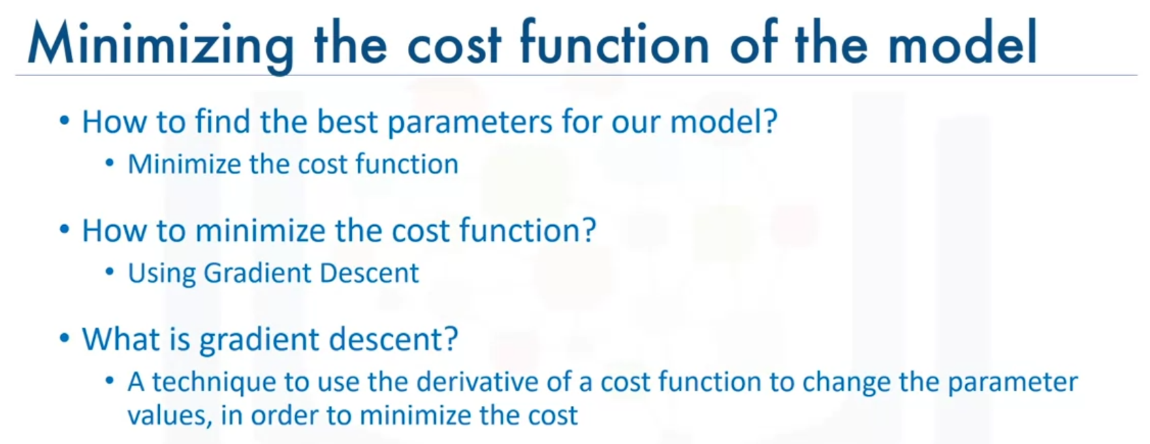

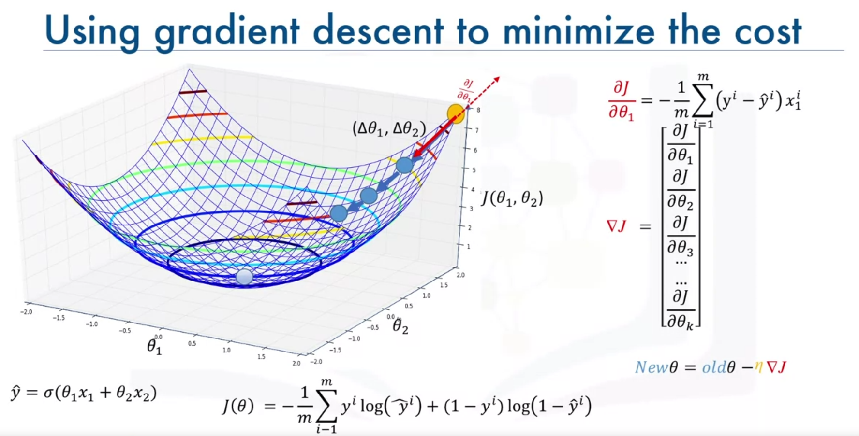

What is "gradient descent" in training process? A technique to use derivative of a cost function to change the parameter values, to minimize the cost.

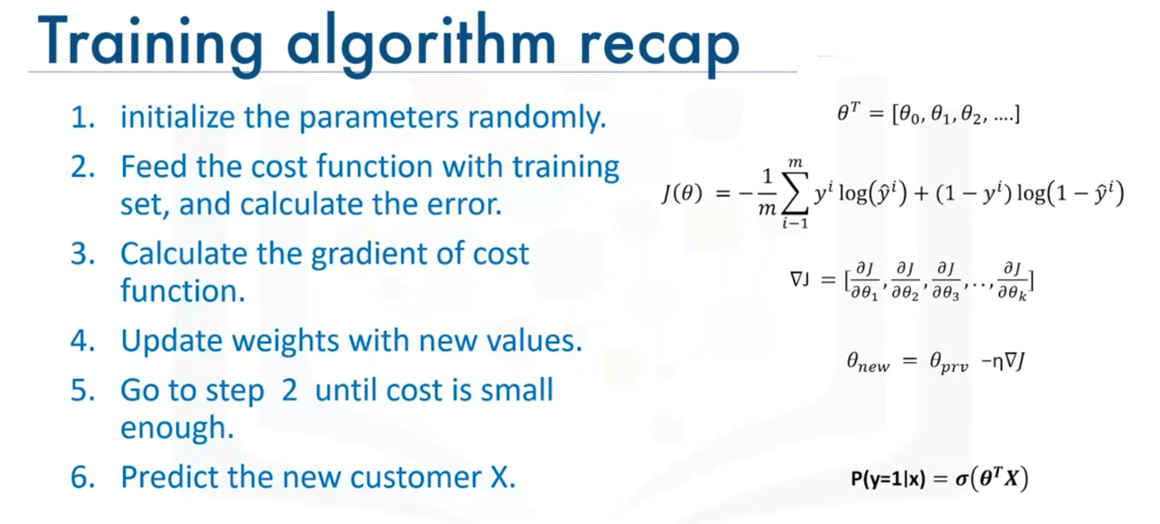

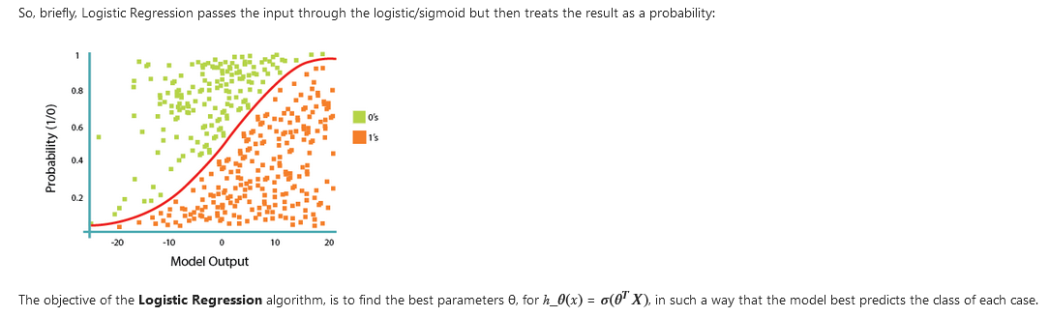

**Support Vector Machine**

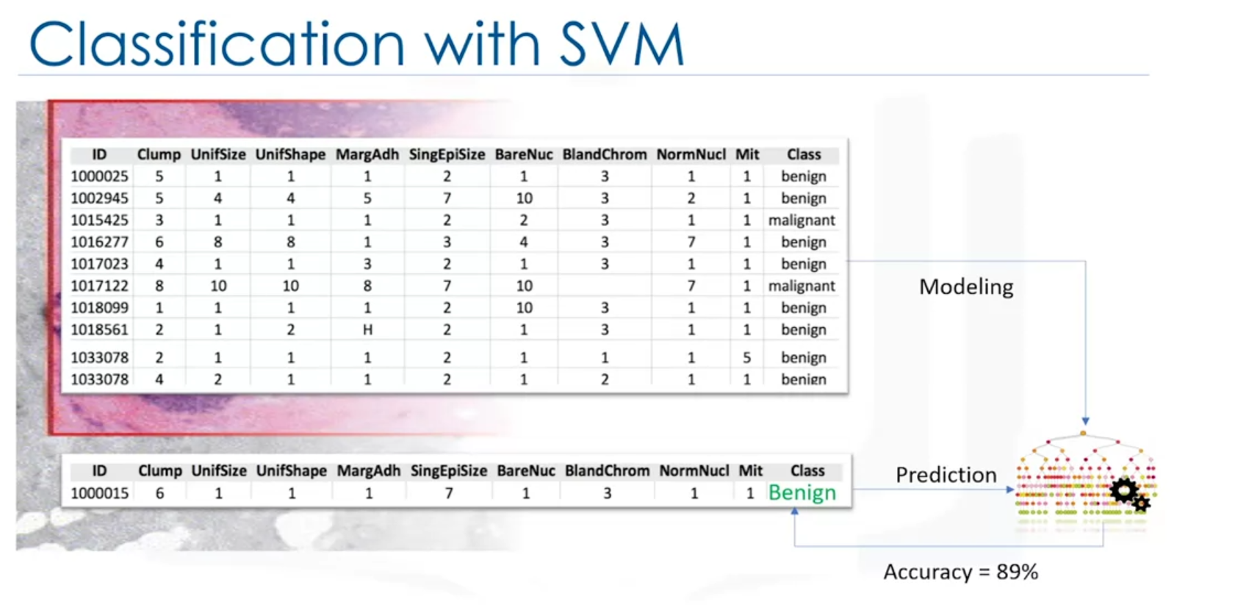

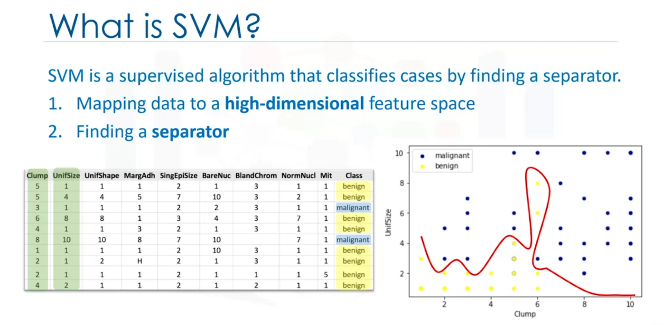

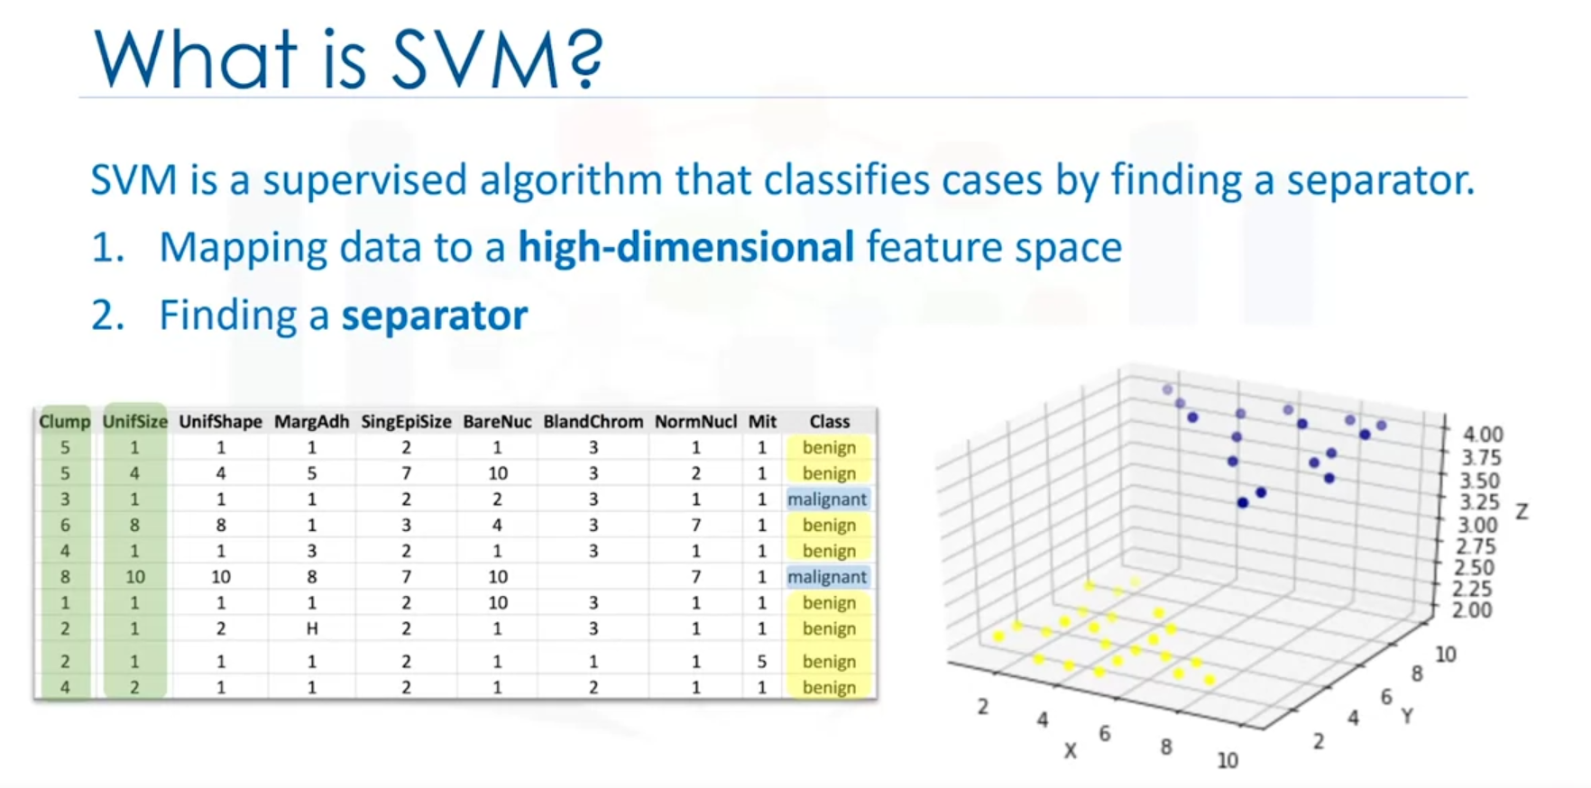

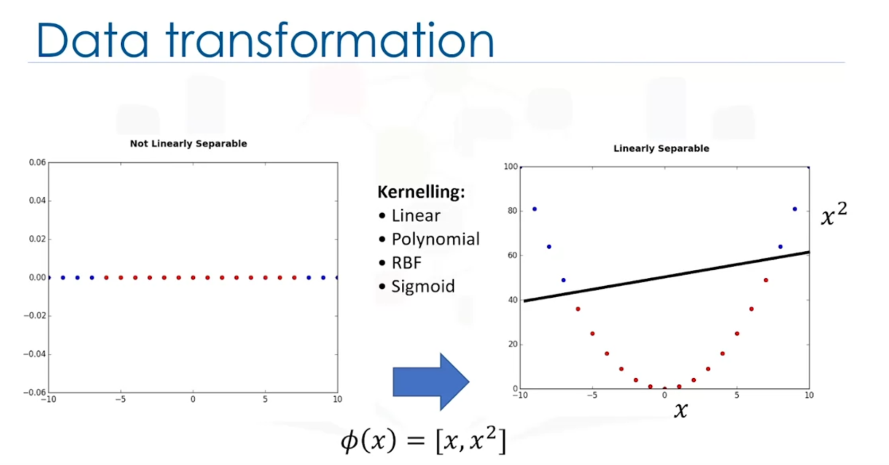

* What is the meaning of "Kernelling" in SVM? Mapping data into a higher dimensional space, in such a way that can change a linearly inseparable dataset into a linearly separable dataset.

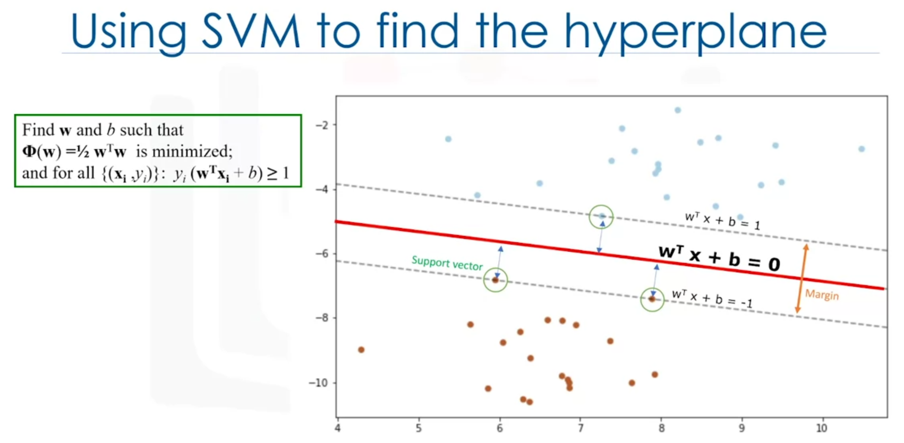

Hyperplane = line that separates blue points from red points.

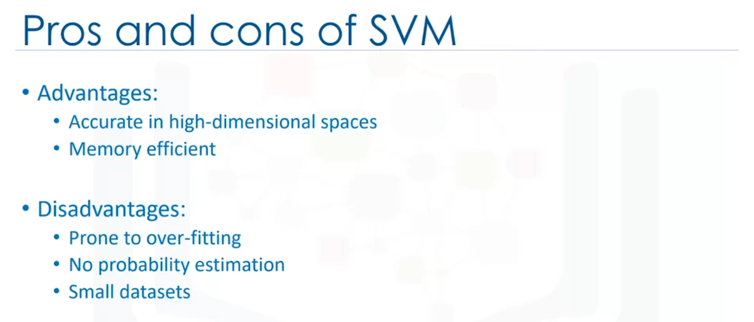

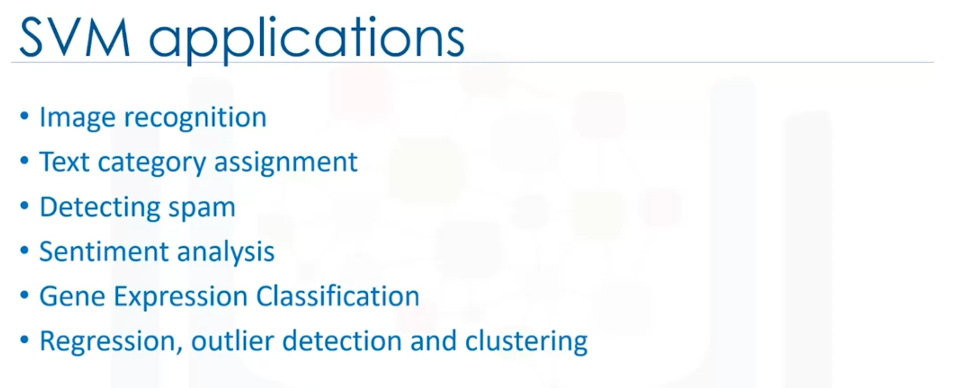

**Other**

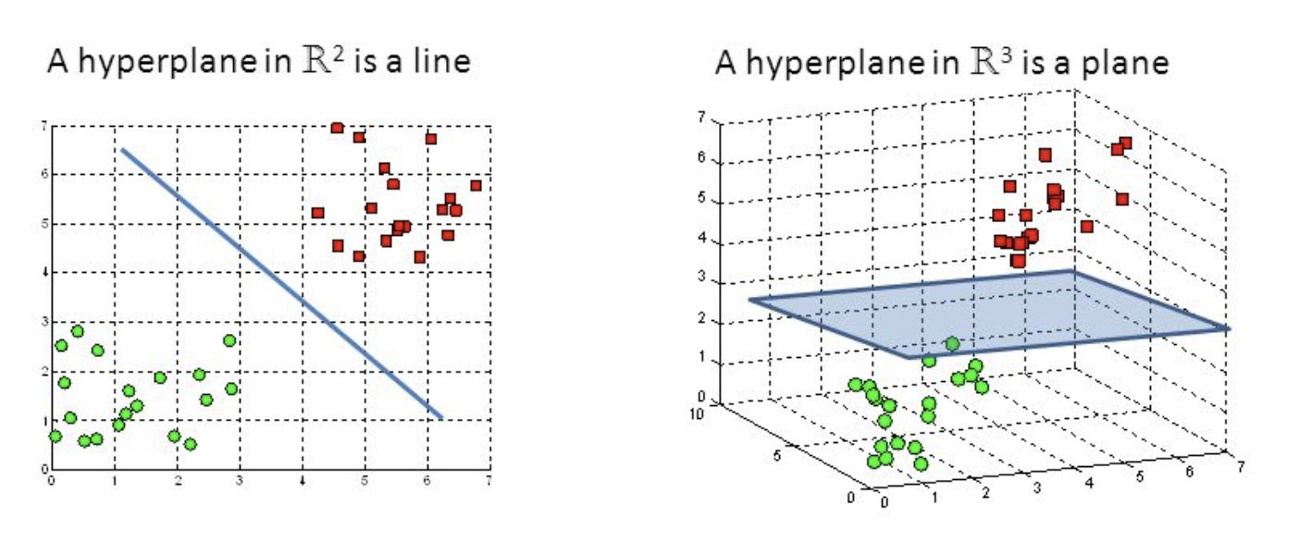

Hyperplane = гиперплоскость

* Which of the following examples is/are a sample application of Logistic Regression?
  + The probability that a person has a heart attack within a specified time period using person's age and sex.
  + Customer's propensity to purchase a product or halt a subscription in marketing applications.
  + Likelihood of a homeowner defaulting on a mortgage.
* Linear regression is used for a continuous target whereas logistic regression is more suitable for a categorical target.
* How are gradient descent and learning rate used in logistic regression?
  + Gradient descent specifies the steps to take in the current slope direction, learning rate is the step length.